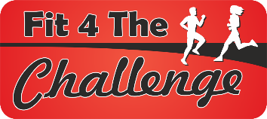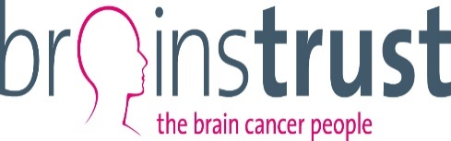

Agree to the Fit4the challenge Terms and Conditions
The entrant must agree to the following terms and conditions prior to booking their place in the event.

I agree to abide by the rules of the event and that the officials' decision is final.

I confirm that they I have no medical disability that would endanger myself or others by taking part (and I will not run if unfit on the day).

I confirm that If I am showing signs of Covid-19 I will not attend the event on 27th November,

I understand that the organisers will not be liable for any loss, damage, injury or illness howsoever caused as a result of entering the race.

I agree that during the race I will obey marshals' instructions, keep to the left hand side of the road and not cross to the other side of the road unless informed to do otherwise by an official.

In the unfortunate cancellation of the event through circumstances beyond the control of the race organisers, I understand and accept the rules and terms of the entry including that there will be no refund of race entries.

If I am unable to take part I understand that there will be no refund of race entries and I will not allow anyone else to use my number without completing the official transfer process (contact the race organiser at ashley.hawkins3@btinternet.com if you wish to transfer your race entry).

Free race transfers will only be possible up until 21st October. After this date there will be a £5 fee for transferring your place to another runner. Transfers will not be possible after 31st October and if you are unable to run after the 31st your place will be offered to a runner on the Reserve List.

I understand that, due to safety concerns, the race organisers do not recommend the use of headphones at races and runners use these at their own risk..

I understand that runners are now required to bring their mobile phones on race day so that they can contact the Race Director or First Aid if needed on race day.

I understand that photographs may be taken of me during the race by the race photography and confirm that I am happy for my image to be used on any future race publicity materials including race posters, photographs on the race website or on race publicity flyers.

By entering this event, I give consent for Fit4thechallenge to store my details on a database and to contact me about future Fit4thechallenge events only. In line with GDPR guidance by entering this race I opt in to receiving emails from fit4thechallenge regarding future events and understand that I need to email fit4thechallenege at info@fit4thechallenge.co.uk if I decide to opt out of being on the race database in future years.

