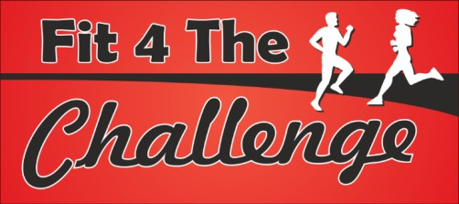BASSINGBOURN BELLE 10 MILER 2021 – RACE HEADQUARTERS -

*Due to the ongoing Pandemic and uncertainty over what the Winter months will bring the 2021 will be scaled down from previous years with no baggage area no refreshments or food stalls, no massage, and no Trophy presentation. There will still be category winners who will be notified after the race by email and will receive a £5 discount on next year’s race, should they wish to return! There will be cash prizes of £50 for beating the male and female course records.

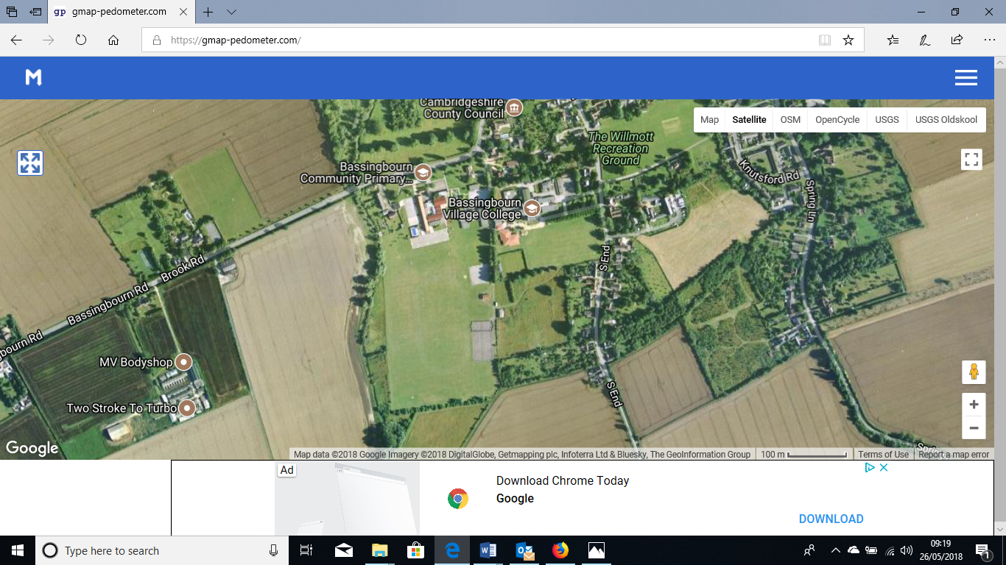

The refreshments area will be kept away from the Race HQ and will managed by vendor. Drinks will need to be consumed in this area only and not taken into the race hq area to ensure social distancing and queueing. Food vendor will have sanitiser on his unit and tables will be wiped down regularly with a sanitizing solution.



Location of pavilion. This area for baggage drop off, toilets and changing rooms.



**KEY**

 Organisers parking only / no runners vehicles allowed

 Runners car park areas  Start /finish point

 Route to the pavilion

 Race Info HQ – medals, water and goodies will be available for runners to collect when they have finished the race.

 First Aid

 Timing Tent

 No runner access

 Refreshments Stall